Most courses within the CNAS and CSIA degree programs are aligned with certifications for which discounted vouchers can be purchased. These courses are shown below:

|  |  |  |
| --- | --- | --- |
| Course | Certification | Discount? |
| CMIT 202 | CompTIA A+ (2 exams, 1001 and 1002) | Yes |
| CMIT 265 | CompTIA Network+ | Yes |
| CMIT 320 | CompTIA Security+ | Yes |
| CMIT 321 | EC-Council CEHv11 | Yes |
| CMIT 326 | CompTIA Cloud+ | Yes |
| CMIT 326 | AWS Certified Cloud Practitioner | No |
| CMIT 336 | Microsoft Azure Fundamentals (AZ-900) | Yes |
| CMIT 350 | Cisco CCNAv7 | No |
| CMIT 380 | Microsoft MD-100 | Yes |
| CMIT 382 | Microsoft MS-100 | Yes |
| CMIT 386 | CompTIA PenTest+ | Yes |
| CMIT 391 | CompTIA Linux+ | Yes |
| CMIT 420 | Microsoft MD-101 | Yes |
| CMIT 421 | CompTIA CySA+ | Yes |
| CMIT 422 | Microsoft MS-101 | Yes |
| CMIT 424 | Certified Computer Examiner (CCE) | No |
| CMIT 426 | AWS Certified Solutions Architect (Associate) | Yes[1] |
| CMIT 436 | (ISC)2 Certified Cloud Security Professional (CCSP) | No |
| CMIT 425 | (ISC)2 Certified Information Systems Security Professional (CISSP) | No |
| CMIT 455 | Cisco CCNP (ENCOR) | No |
| CMIT 456 | Cisco CCNP (ENARSI) | No |
| CMIT 460 | Computer Security Incident Handler (CSIH) | No |
| CSIA 300 | Certified Secure Computer User (C|SCU) v2 | Yes |
| CSIA 310 | Certified Incident Handler (E|CIH) v2 | Yes |
| CSIA 413 | Certified Information Privacy Professional (CIPP/US) | No |
| CSIA 485 | Certified Chief Information Security Officer (C|CISO) | Yes |

As a UMGC student, you are eligible for discounts on CompTIA certification exams.

If you plan to take a CompTIA certification exam, visit <https://academic-store.comptia.org/?location=academic>. Use your student email address to buy the voucher at a discount. Discounted vouchers are available for the following pricing:

|  |  |  |  |  |
| --- | --- | --- | --- | --- |
|  | Student Pricing | Regular Pricing | $ Savings | % Savings |
| A+ (CORE 1) | $106.00 | $232.00 | $126.00 | 54.31% |
| A+ (CORE 2) | $106.00 | $232.00 | $126.00 | 54.31% |
| CASP+ | $336.00 | $466.00 | $130.00 | 27.90% |
| Cloud+ | $163.00 | $338.00 | $175.00 | 51.78% |
| CySA+ | $240.00 | $370.00 | $130.00 | 35.14% |
| ITF+ | $78.00 | $126.00 | $48.00 | 38.10% |
| Linux+ | $163.00 | $338.00 | $175.00 | 51.78% |
| Network+ | $163.00 | $338.00 | $175.00 | 51.78% |
| PenTest+ | $240.00 | $370.00 | $130.00 | 35.14% |
| Project+ | $163.00 | $338.00 | $175.00 | 51.78% |
| Security+ | $240.00 | $370.00 | $130.00 | 35.14% |
| Server+ | $163.00 | $338.00 | $175.00 | 51.78% |
| *Note: Pricing as of November 9, 2020, via https://academic-store.comptia.org/.* | | | | |

**Additional Instructions:**

The link: <https://academic-store.comptia.org/?location=academic> is only for Students purchasing at the academic rate.

1. You will need to create an account and provide the following information:

* First Name
* Last Name
* School Email Address
* Password
* Confirm Password
* Agree to the Privacy Policy by providing personal information, consent to the collection and use and transfer of personal data to Pearson VUE and its authorized third parties.

You will receive a confirmation email to the email address you used during sign-up:

1. BackRegister for the CompTIA exam/create an account

CompTIA Customer Service - [help@comptiastore.com](mailto:help@comptiastore.com) 855-863-9241

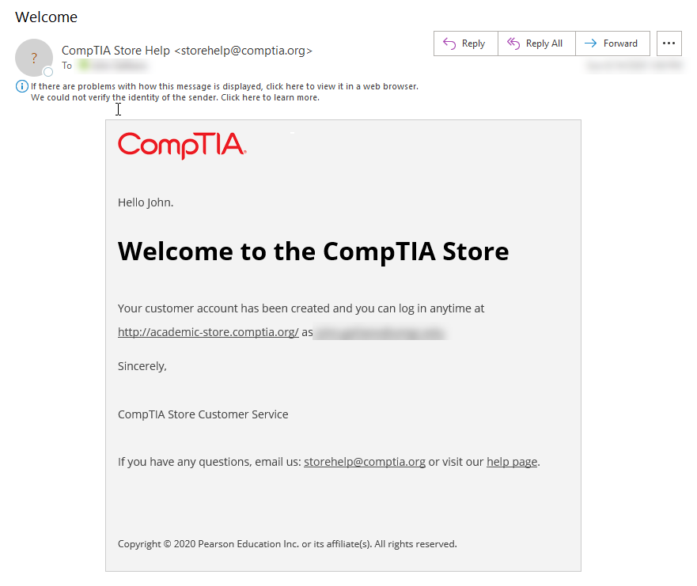

2. You can now login and shop on the academic store. At checkout, you will be asked to provide eligibility information that will be used by *Sheer ID*, a third-party service that provides verification of your UMGC student status to CompTIA.

3. Type in our school’s name: University of Maryland Global Campus (which is on the list).

4. Enter your Birth Year, Month, and Date and click the ‘Submit’ button.

Note: *Sheer ID* will complete the verification and you will see “Congratulations, we've successfully verified your eligibility as a student.”

5. Click the “Complete your checkout” or “Continue Shopping” link.

NOTE: For the purchase of Exam Vouchers or CertMaster Learning, the following rules apply:

• The quantity you place in your cart for a single line item of either product is limited to one (1)

• You are limited to buying four (4) vouchers and six (6) digital products in a 6-month period

• Total lifetime purchases of either product may not exceed ten (10)

As a UMGC student, you are eligible for discounts on EC-Council certification exams.

**For C|SCU (CSIA 300),** the voucher price with remote proctoring is $25.00

**For E|CIH (CSIA 310),** the voucher price with remote proctoring is $149.00

**For C|CISO (CSIA 485),** the voucher price with remote proctoring is $500.00; you must submit the experience verification form before being allowed to purchase the voucher.

**For CEH (CMIT 321):** The International Council of Ecommerce Consultants (EC-Council) offers a partnership with UMGC for CMIT 321 for currently enrolled students and former students of the course:

* **You can purchase a Certified Ethical Hacker (CEH) Certification Voucher for Only $400.00 (normal pricing $1199.00).**
* **You will not have to pay the $100 qualification fee.**

NOTE: You must be enrolled in the supporting course and have purchased the associated official EC-Council eCourseware. Due to aggressive course and exam refresh cycles, EC-Council recommends attempting the exam within two years of taking the class.

**HOW TO ORDER EC-COUNCIL VOUCHERS:** Email ace@eccouncil.org with Subject Line: “Voucher Request - UMGC”. You must include the following information:

• First Name  
• Last Name  
• Course Acronym  
• Email Address  
• Phone Number  
• Address (For Billing Purposes)

Within 48 hours of your email, an EC-Council representative will contact you with payment instructions.  
After your payment is processed, you will receive your voucher within 24 hours.

EC-Council Exam Vouchers are redeemable through the ECC Exam Center at <https://www.eccexam.com>

Back

As a UMGC student, you are eligible for discounts on Microsoft certification exams.

You can get a discounted voucher from $91.00 instead of the full price of $165. Here is a link and process [https://wsr.pearsonvue.com/vouchers/pricelist/microsoft.asp](https://nam03.safelinks.protection.outlook.com/?url=https%3A%2F%2Fwsr.pearsonvue.com%2Fvouchers%2Fpricelist%2Fmicrosoft.asp&data=02%7C01%7CJohn.Galliano%40umgc.edu%7Cec7cf7d2915c4af6e2aa08d8573612b8%7C704ce3d6a4bf4e098516d52840c9f7a9%7C0%7C0%7C637355237057667135&sdata=HmNwtxFkbviwUoK2ZVxYTVe3Kq1RiYf4z%2BcvZA%2F5MWk%3D&reserved=0)

Machine generated alternative text:
Microsoft 
9 
0 00 
Exam: 
MD-IOO: Windows 10 
View Testing Policies 
Price*. 
USD 91.00 
Language: 
English 
System Requirements: 
Exam details 
MD-IOO: Windows 10 
ALERT: Before you register for an online proctored exam, review the system requirements, check the list of participating countries, read about the 
testing protocols, and complete the required system test: Online Proctoring Required Information 
*Prices listed are based on today's date and do not include local taxes which may be applicable. 
Previous 
Next 

Back

As a UMGC student, you are eligible for discounts on AWS certification exams.

### **How to Get Free AWS-Certified Cloud Practice Exams**

Although it is not a requirement for this course, it is strongly recommended you complete practice exams before scheduling your certification exam.

Contact your instructor if you want a voucher for the AWS Cloud Practitioner Practice Exam. Your instructor will give you a voucher/discount coupon. Use that code on the payment screen at AWS: Instructions for Scheduling a Practice Exam With AWS.

### **How to Buy AWS Cloud Certification Exam Vouchers at a Discount**

As a UMGC student, you are eligible for a 50 percent discount on the AWS Cloud Practitioner certification exam. To get the voucher/discount coupon, please email your instructor. Allow three to five days for the processing of the vouchers. Once you receive the voucher discount code, follow the Instructions for Scheduling Certification Exams, and enter the voucher/discount coupon number from xVoucher at the payment screen.

Back

1. *After successfully passing the AWS Certified Cloud Practitioner certification exam, students may qualify for an additional voucher at 50% discount*